Computer Networks: ITEC611 (Troubleshooting)

Full Name: Amir Tamang Student Number: S00393664

Part A:
No. | Ticket Desc. | Problem | Show Command Used | Command to fix the problem
Example | R1 cannot ping VLAN 5  on MGT-SW | The IP address & subnet mask are not configured correctly | MGT-SW# Show ip interface brief  MGT-SW# Show interface vlan 5 | MGT-SW# configure terminal  MGT-SW (config)# int vlan 5  MGT-SW(if-config)# ip add 5.5.5.10 255.255.255.0
1. | SW0 cannot ping  Vlan 1 on SW2 | VLAN 1 is not configured on SW2  (1 mark) | SW2# show ip interface brief  SW2# show interface vlan 1  (1 mark) | SW2# configure terminal  SW2(config)# interface vlan 1  SW2(if-config)# ip address 192.168.1.2 255.255.255.0  SW2(if-config)# no shutdown  (2 marks)
2. | R3 is unable to get ping response from R1’s Loopback 0. | Routing or IP configuration issue  (1 mark) | R1# show ip interface brief  R3# show ip route  (1 mark) | R1# configure terminal  R1(config)# interface loopback 0  R1(if-config)# ip address 192.168.7.1 255.255.255.0  R1(if-config)# no shutdown  (2 marks)
3. | SW1 is not reachable from R3. | VLAN or routing configuration issue  (1 mark) | SW1# show ip interface brief  R3# show ip route  (1 mark) | SW1# configure terminal  SW1(config)# interface vlan 1  SW1(if-config)# ip address 192.168.2.125 255.255.255.0  SW1(if-config)# no shutdown  (2 marks)
4. | Identify the IOS version, NVRAM and ROM size for R2 router | IOS version:  Version 15.1(4) M4  (1 mark) | Show command:  R2# Show version  (1mark) | NVRAM: 255K bytes  ROM: System Bootstrap  (2 marks)

Part B:
- Identify the route (IP addresses) a packet takes to go from SW0 to Lo1 on R3. What command (write the full command) did you use for the above? (2 marks)
- SW0# traceroute 200.200.200.1

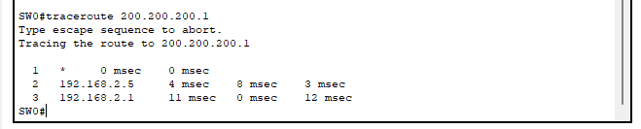

- Calculate the average round trip time (RTT) for the following route: SW0 ->SW2. What command (full command) did you use to find the RTT value? (2 marks)
- The code I used to find the RTT value is:
SW0# ping 192.168.1.2

